POWER QUERY – fxTableReplaceNulls()

/* fxTableReplaceNulls()

A custom function to replace all the null values in a table.
Default values for text, number, and logical columns will
be applied unless optional custom values are provided.

Parameters:
data - a non empty table
replace_info - optional non-empty record with field names and custom replacements
if missing or null, use default text, number, and logical
replacement values

N.B. Proper casing is enforced regarding fields in the record: they much match the
table column names exactly, or Power Query will throw an error.
Interestingly, names of non-existent table columns in the record are ignored and
no errors are thrown.
It is possible to specify a replacement value of a different data type for a given
column. This will convert the column to general format.

*/

(data as table, optional replace_info as record) as any =>

let
//Validations
data_ok = (not Table.IsEmpty(data)) and (Table.ColumnCount(data) > 0),
replace_info_ok = if (not replace_info = null) and (Record.FieldCount(replace_info) <> 0) then true else false,

use_default_replacers = if replace_info = null then true else false,

default_text_replacer = "",
default_number_replacer = 0,
default_logical_replacer = false,

table_schema = Table.Schema(data),
all_text_columns = Table.SelectRows(table_schema, each [Kind] = "text")[Name],
all_number_columns = Table.SelectRows(table_schema, each [Kind] = "number")[Name],
all_logical_columns = Table.SelectRows(table_schema, each [Kind] = "logical")[Name],

custom_replace_columns = Record.FieldNames(replace_info),
custom_replace_text_columns =
List.Intersect({custom_replace_columns, all_text_columns}, Comparer.OrdinalIgnoreCase),
custom_replace_number_columns =
List.Intersect({custom_replace_columns, all_number_columns}, Comparer.OrdinalIgnoreCase),
custom_replace_logical_columns = List.Intersect({custom_replace_columns, all_logical_columns}, Comparer.OrdinalIgnoreCase),

//Encapsulate logic for processing each type of replacement in a standalone
//function, for more readable and maintainable code
//Otherwise there will be too many indented levels, too many similar labels for
//complex expressions. By placing each type of logic in its own function,
//code is also easier to write.
fxReplaceWithDefaults =
(input_table as table, field_names as list, default_replace_value as any) as table =>
let
replace_values =
if not List.IsEmpty(field_names) then
Table.ReplaceValue(input_table, null, default_replace_value,
Replacer.ReplaceValue, field_names)
else
input_table

in
replace_values,

fxCallDefaultReplacers =
() as table =>
let
default_replaced_text_nulls =
fxReplaceWithDefaults(data, all_text_columns, default_text_replacer),
default_replaced_number_nulls =
fxReplaceWithDefaults(default_replaced_text_nulls, all_number_columns, default_number_replacer),
default_replaced_logical_nulls =
fxReplaceWithDefaults(default_replaced_number_nulls, all_logical_columns, default_logical_replacer)
in
default_replaced_logical_nulls,

fxCustomTextFieldReplacer =
(input_table as table) as table =>
if custom_replace_text_columns <> {} then
List.Accumulate(
custom_replace_text_columns,
input_table,
(state, current) =>
let
custom_field_replacer = Record.Field(replace_info, current),
replaced_custom_field =
Table.ReplaceValue(state, null, custom_field_replacer,
Replacer.ReplaceValue, {current})
in
replaced_custom_field)
else
input_table,

fxCustomNumberFieldReplacer =
(input_table as table) as table =>
if custom_replace_number_columns <> {} then
List.Accumulate(
custom_replace_number_columns,
input_table,
(state, current) =>
let
custom_field_replacer = Record.Field(replace_info, current),
replaced_custom_field =
Table.ReplaceValue(state, null, custom_field_replacer,
Replacer.ReplaceValue, {current})
in
replaced_custom_field)
else
input_table,

fxCustomLogicalFieldReplacer =
(input_table as table) as table =>
if custom_replace_logical_columns <> {} then
List.Accumulate(
custom_replace_logical_columns,
input_table,
(state, current) =>
let
custom_field_replacer = Record.Field(replace_info, current),
replaced_custom_field =
Table.ReplaceValue(state, null, custom_field_replacer,
Replacer.ReplaceValue, {current})
in
replaced_custom_field)
else
input_table,

replaced_nulls =
if data_ok and use_default_replacers then
fxCallDefaultReplacers()
else
let
replace_text_fields = fxCustomTextFieldReplacer(data),
replace_number_fields = fxCustomNumberFieldReplacer(replace_text_fields),
replace_logical_fields = fxCustomLogicalFieldReplacer(replace_number_fields)
in
replace_logical_fields

in
replaced_nulls

TESTING SUITE

/* Testing fxTableReplaceNulls()

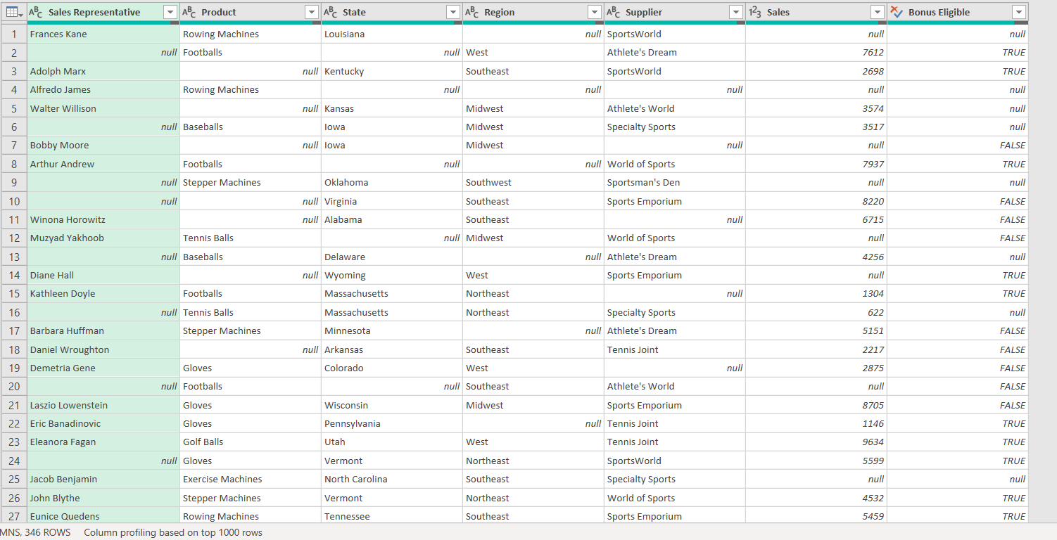

Case #1:
data: SalesData
replace_info: missing
output: fxTableReplaceNulls_Case #1
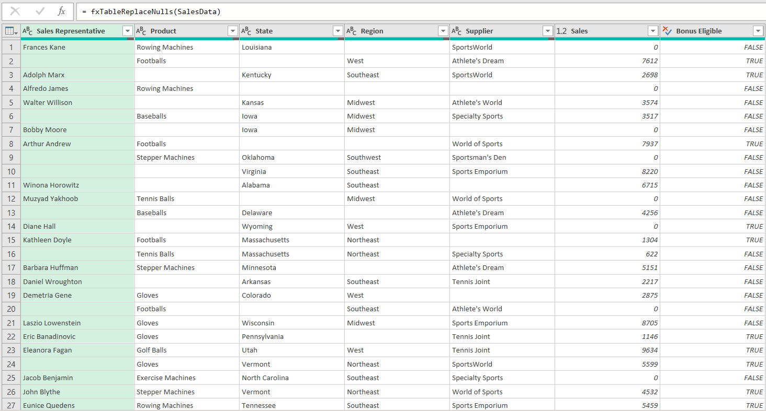

Case #2:
data: SalesData
replace_info: [Product = "NEW PRODUCT!"]
output: fxTableReplaceNulls_Case #2
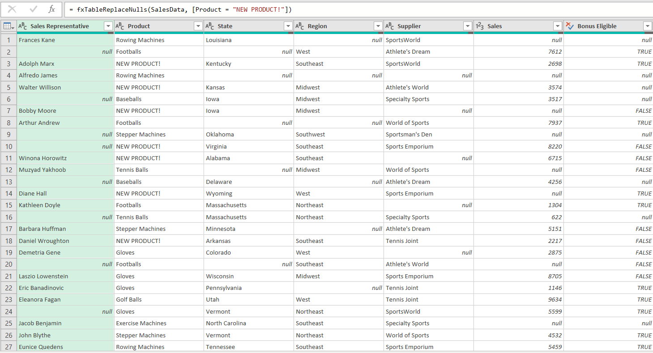

Case #3:
data: SalesData
replace_info: [State = "NEW STATE!", Region = "NEW REGION!"]
output: fxTableReplaceNulls_Case #3

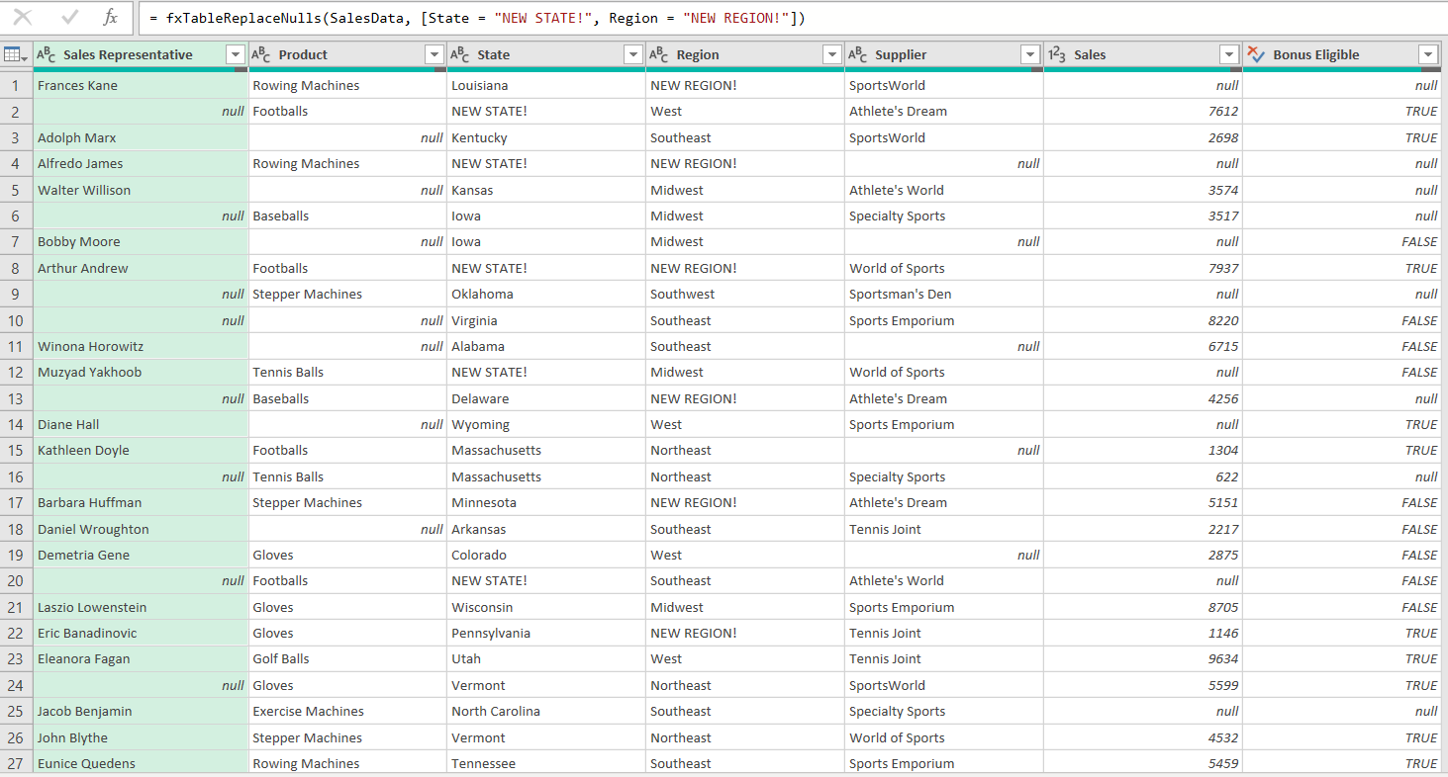

Case #4:
data: SalesData
replace_info: [Sales Representative = "NEW SALES REP!", Supplier = "NEW SUPPLIER!", Sales = 999.99]
output: fxTableReplaceNulls_Case #4
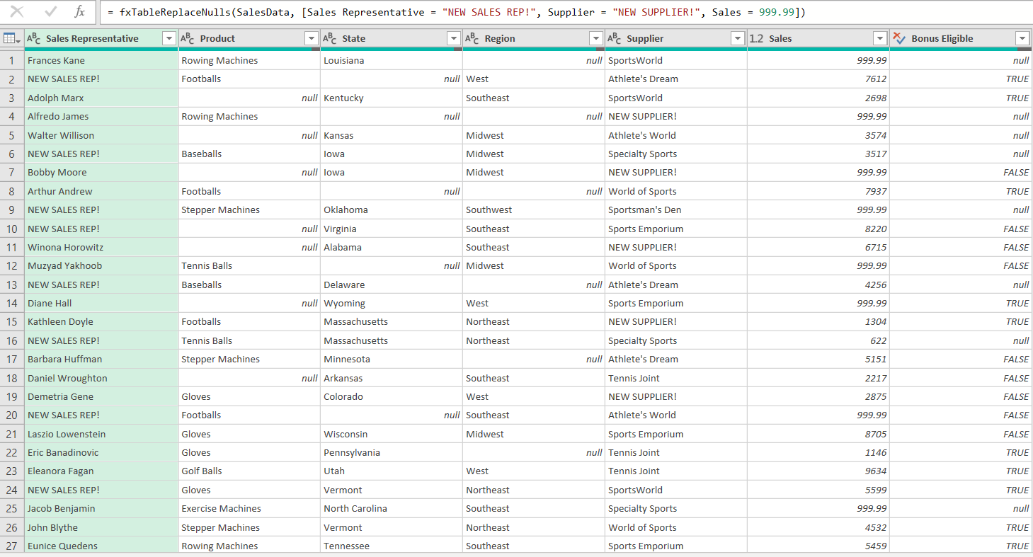

Case #5:
data: SalesData
replace_info: [pRodUct = "NEW PRODUCT!", BOnuS eLIgiblE = true, regiON = "NEW REGION!"]
output: fxTableReplaceNulls_Case #5
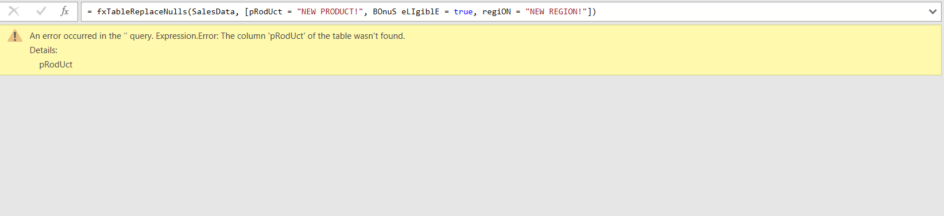

Case #6:
data: SalesData
replace_info: [Product = "NEW PRODUCT!", Product = "OLD PRODUCT!"]
output: fxTableReplaceNulls_Case #6
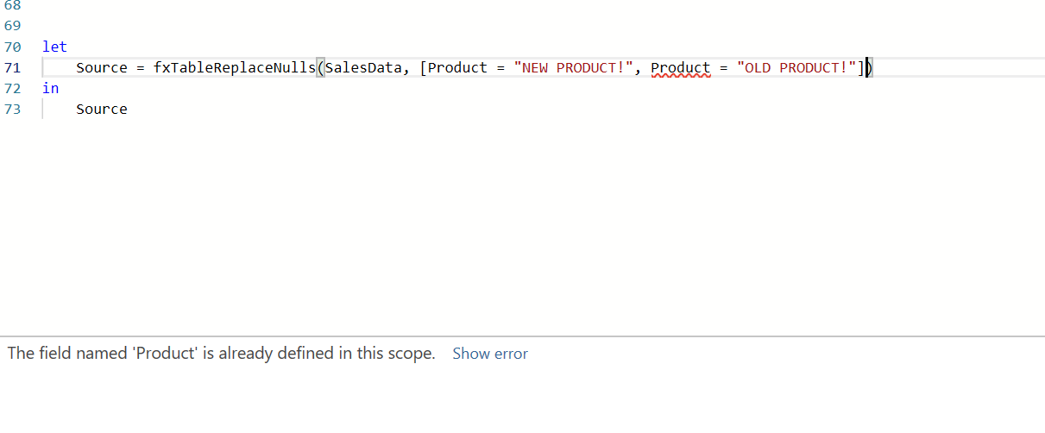

Case #7:
data: SalesData
replace_info: [Sales = 101.99, Bonus Eligible = "Maybe?"]
output: fxTableReplaceNulls_Case #7
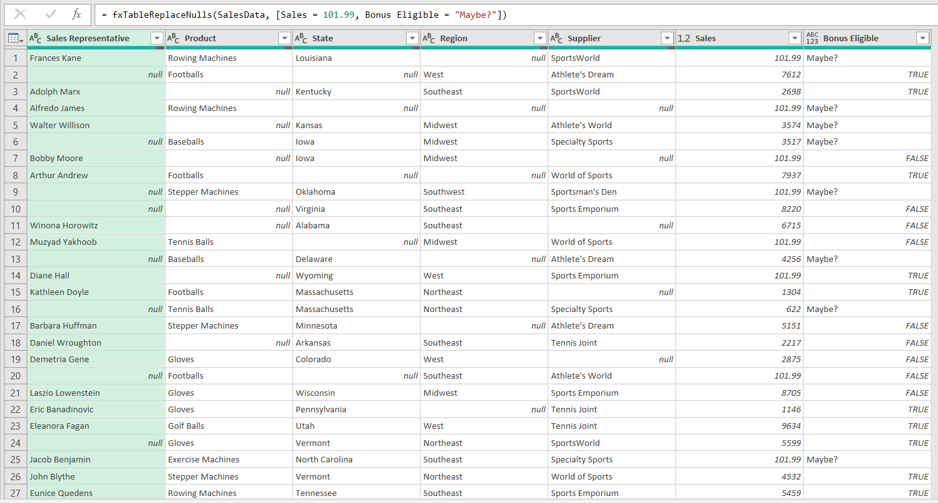

Case #8:
data: SalesData
replace_info: [Sales Representative = false, Region = 100.99]
output: fxTableReplaceNulls_Case #8
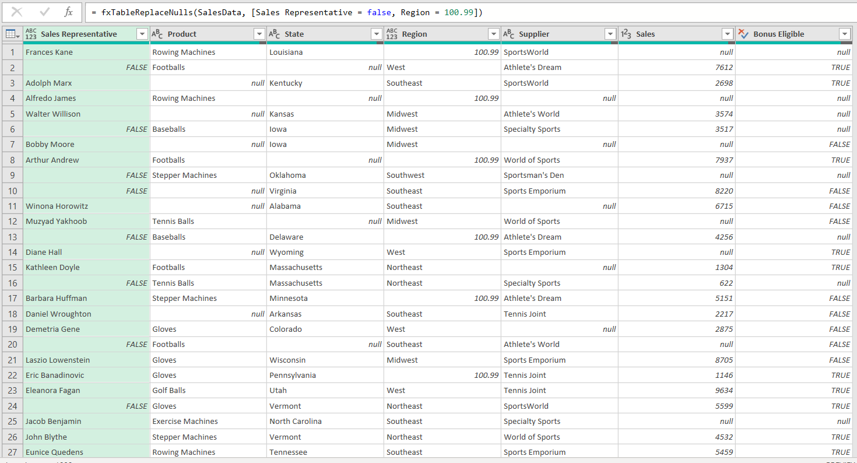

Case #9:
data: SalesData
replace_info: [New Table Field = "NEW FIELD!", Region = "NEW REGION!", Sales = 101.99]
output: fxTableReplaceNulls_Case #9
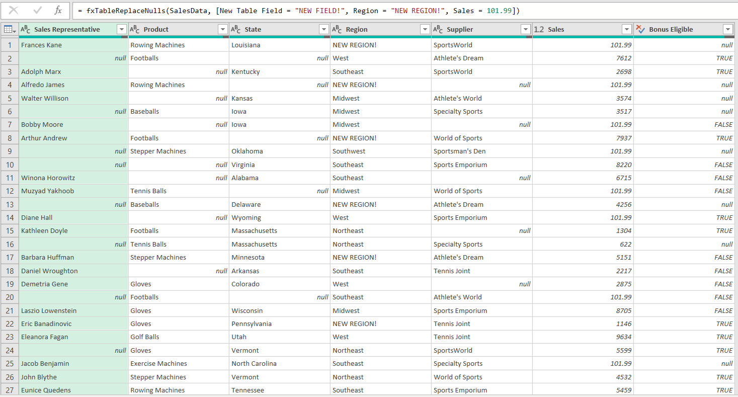

Case #10:
data: SalesData
replace_info: [Sales = 101.99, Region = "NEW REGION!", Sales Representative = "NEW SALES REP!"]
output: fxTableReplaceNulls_Case #10
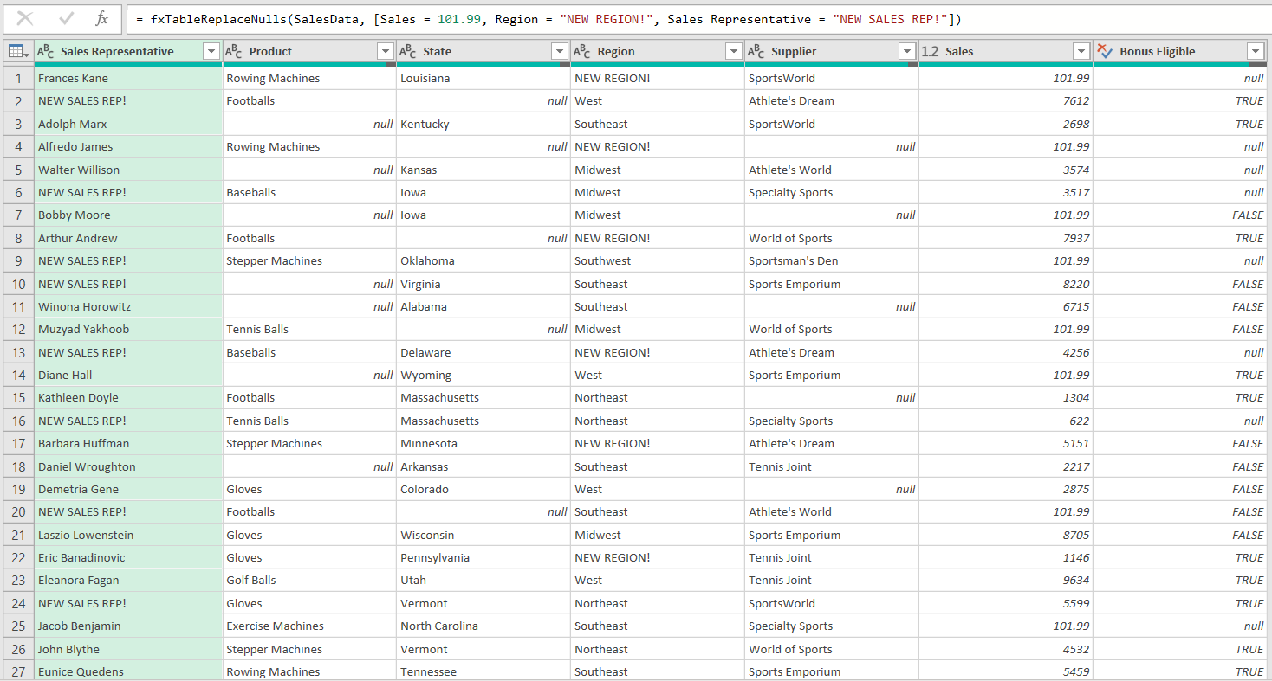

Case #11:
data: SalesData
replace_info: null
output: fxTableReplaceNulls_Case #11
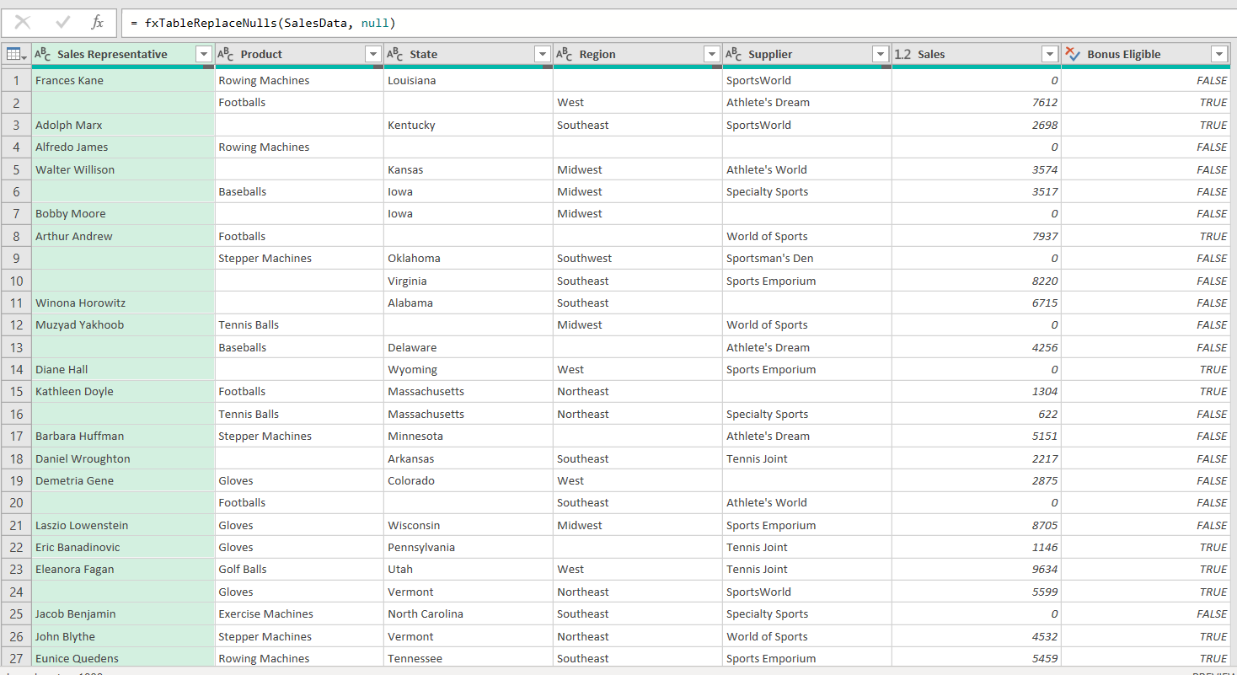

Case #12:
data: SalesData
replace_info: [Product = null, Sales = null, Region = "NEW REGION!"]
output: fxTableReplaceNulls_Case #12




